

**Synbiotic to Attenuate Resorption of the Skeleton**

***Volunteers needed for a clinical trial to promote***

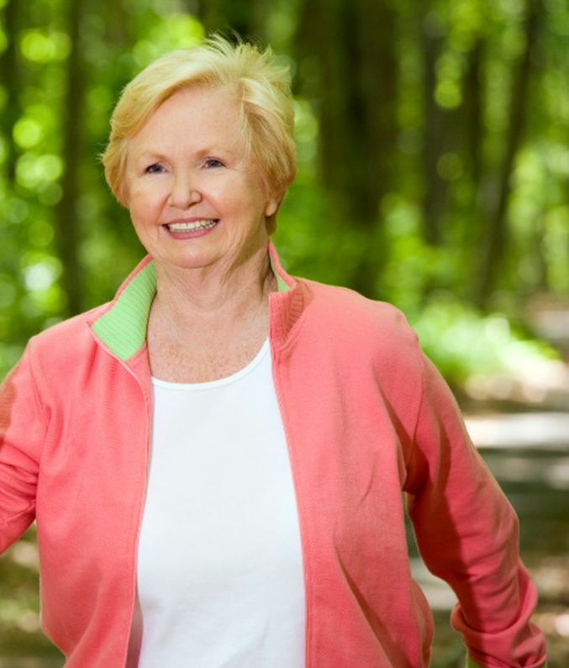***Better Bone Health***

Did You Know?

There are two phases of bone loss in women, the bone loss that occurs around the time of menopause and the ongoing bone loss that occurs well beyond menopause.

We are testing whether capsules containing probiotics and plant fiber will keep your bones healthy.

Who Can Participate?

* Women aged 60 years or older
* Meet all eligibility criteria
* Willing to participate in an 18-month trial taking twice-daily capsules
* Willing to come for four 1-hour in-person study visits

Two-$50 gift cards for participation and transportation will be provided if necessary

to all research visits.

**For more information on what is involved and how to participate**

**in this study, contact the site study coordinator:**

**Evelyn O’Neill at (617) 971-5800 or email** [**oneill@hsl.harvard.edu**](mailto:oneill@hsl.harvard.edu)

**This study is being led by Dr. Shivani Sahni PhD & Dr. Douglas Kiel, MD MPH at the**

**Marcus Institute on Aging Research Hebrew SeniorLife.**

